Extra Details

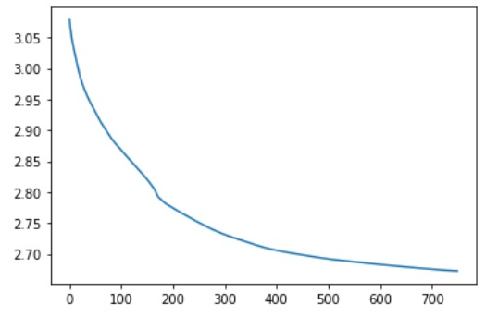

Accuracy on train: 0.59127283

Accuracy on test: 0.5466708

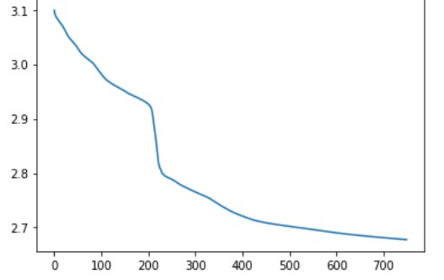

Accuracy on train: 0.5947462

Accuracy on test: 0.5649892

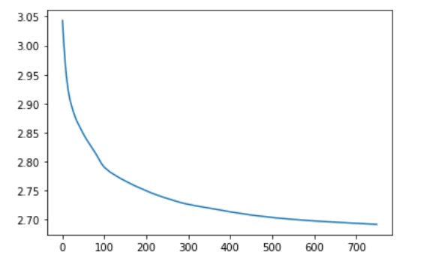

Accuracy on train: 0.59070677

Accuracy on test: 0.5716785

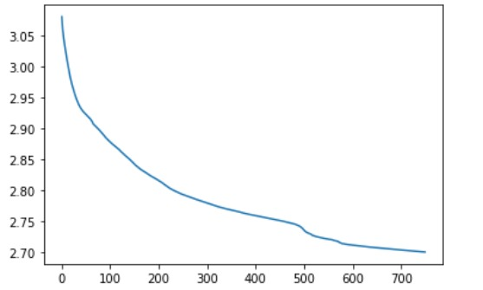

Accuracy on train: 0.5869761

Accuracy on test: 0.5354533

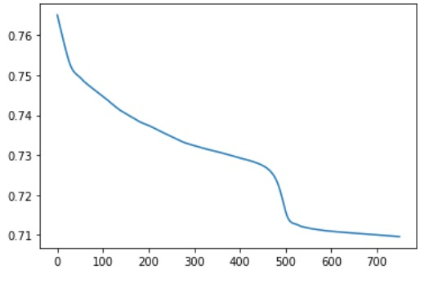

Accuracy on train: 0.55855715

Accuracy on test: 0.5276863

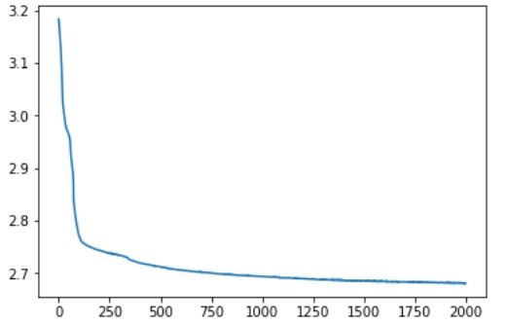

Accuracy on test : 0.64553314